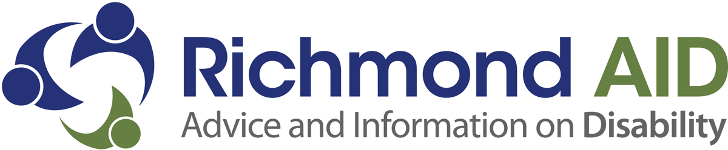

Richmond Advice and Information on Disability (Richmond AID) is an organisation of and for disabled people, working to improve access, choice, quality of life and independence for disabled people in the London Borough of Richmond upon Thames and surrounding areas. We are looking for an enthusiastic, hardworking and highly motivated person to join our team.

We are looking for a dynamic Advice Manager that can lead and support our advices services. We are a growing organisation that strives for excellence.

You will have a passion for social justice, expertise in the advice and social care sector, be able to bring new ideas and implement change in our advice services.
You will also be a great people person, able generate a positive atmosphere in the organisation, ensuring the team are motivated and supported in their roles.

Advice Manager
Salary Range (depending on experience): £28,105 to £32,790 incl. OLW
Closing Date: 5pm Wed 31st May 2017
Interview Date: tbc
This post is full-time (36 hours per week).

The Advice Manager will lead, direct and manage services across the organisation in line with contract and funder requirements. The Operations Manager will have wide ranging responsibilities for the performance, quality assurance and development of internal services and operations and will be responsible for achieving and evidencing high quality positive outcomes for service users.

Richmond AID offer 25 days annual leave plus eight bank holidays pro rata. Normal office hours are 9am to 5.15pm Monday to Thursday and 9am to 5pm on Fridays. You will be based at our offices in the Disability Action and Advice Centre, 4 Waldegrave Road, Teddington, TW11 8HT but may need to work from other locations as needed.

For an application pack, including a full job description and person specification, please go to our website at www.richmondaid.org.uk or contact Lucy Byrne at l.byrne@richmondaid.org.uk. Different formats are available on request. We do not accept CVs as part of our recruitment process.

Richmond AID is an equal opportunities employer and particularly welcomes applications from disabled candidates. Richmond AID has been awarded the Two Ticks symbol meaning any disabled candidates that meet the minimum criteria will be invited for interview.

Regd charity No. 1074788. Company limited by guarantee, Regd in England No. 3612476.

